#1 - Six Sides of Breathing
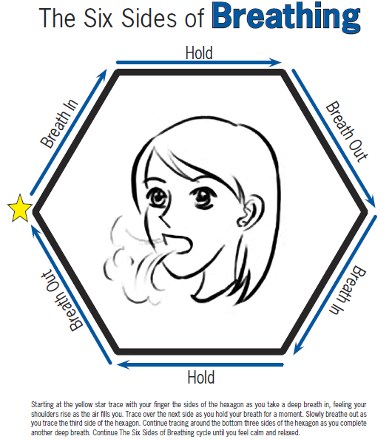
#2 – Squeeze ball/stress ball
Directions: Place the ball in your hand and gently squeeze.

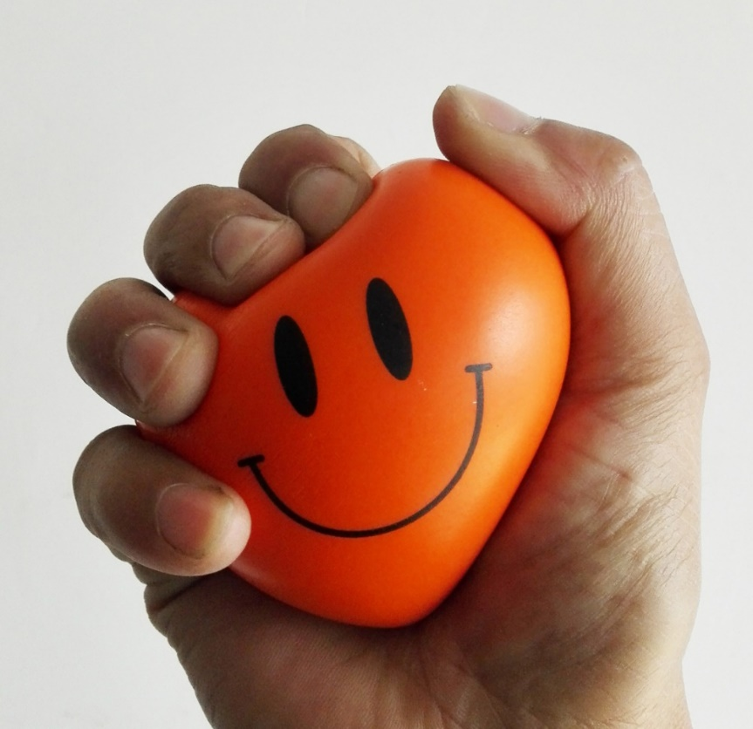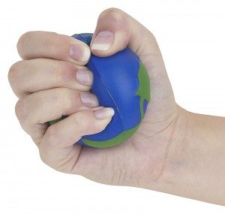

#3 - Hard Stress ball
Directions: Place the ball in your hand and gently squeeze.
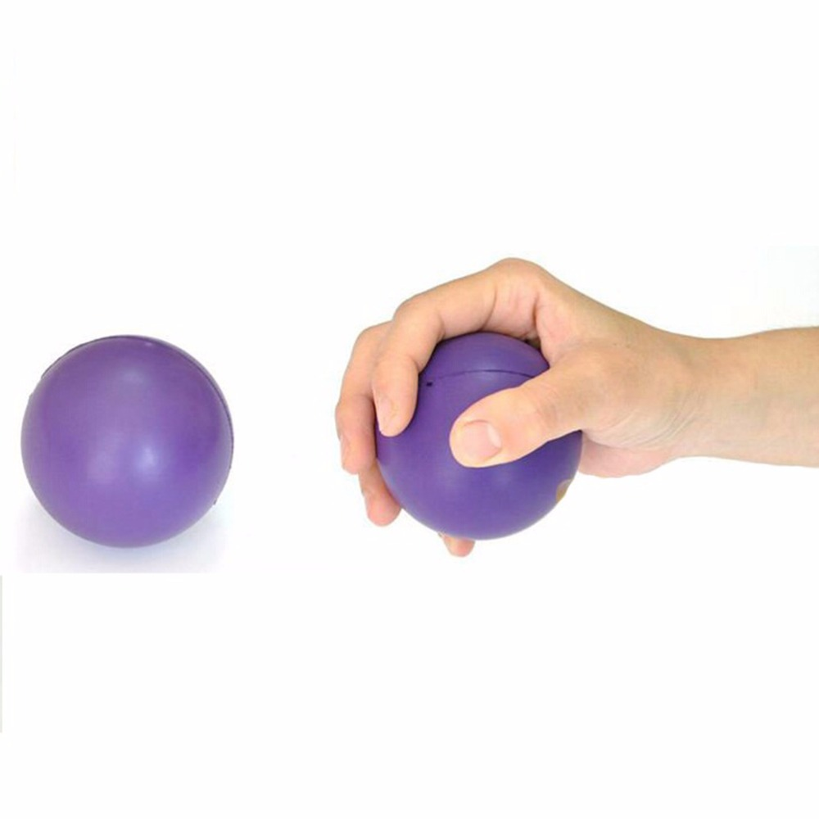
#4 - Small bean bag squeeze
Directions: Place the small bean bag in your hand and gently squeeze.
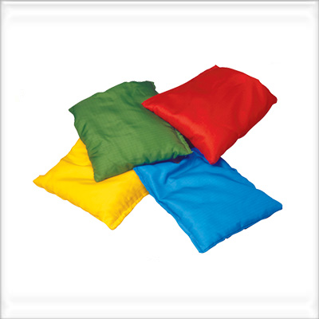
#5 – Putty
Directions: Place the putty in your hand and gently squeeze.
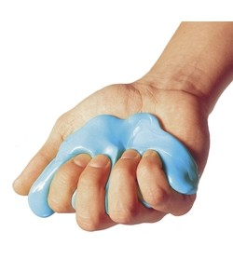
#6 - Lazy 8 Breathing
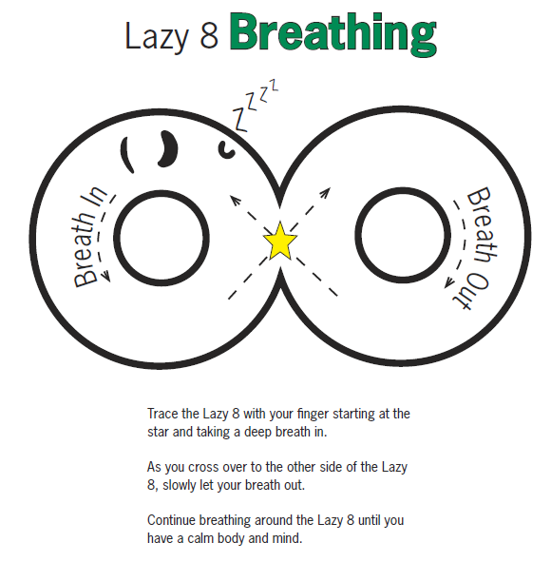
#7 - Digging or hunting on for objects in a rice bin
Directions: SLOWLY dig through the rice with your hand and look for as many objects as you can find.

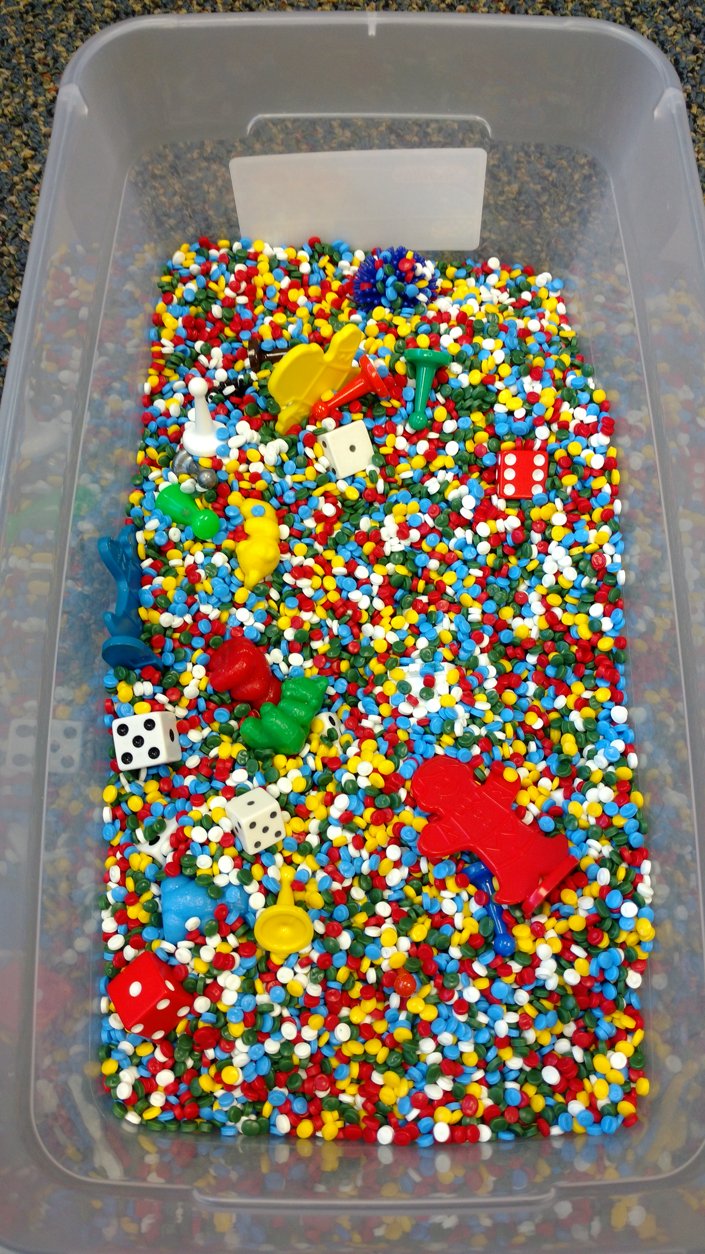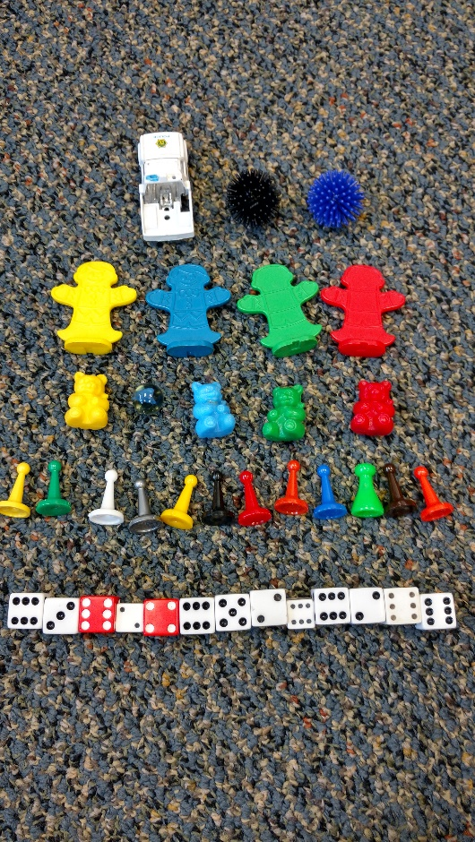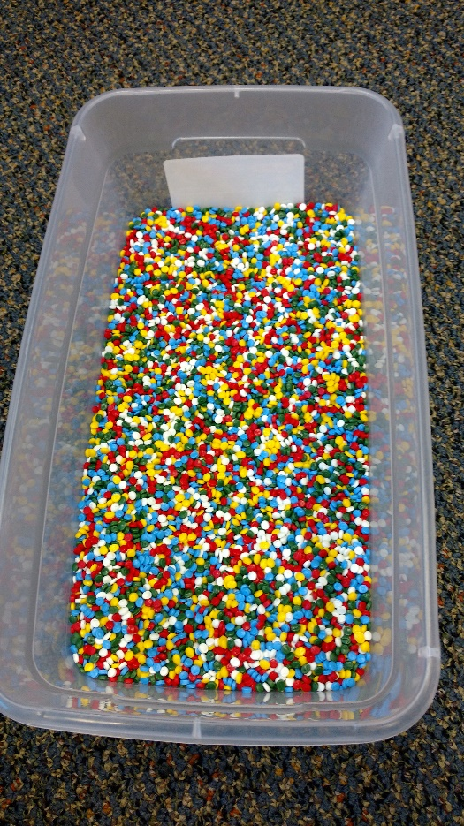
#8 - Sit with a weighted lap pad
Directions: Sit on the chair and place the weighted lap pad on your lap.

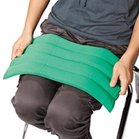
#9 - Wearing noise-cancelling headphones
Directions: Sit on the chair and place the headphones over your ears.

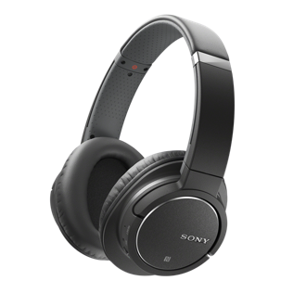
#10 - Wall push-ups
Directions: Put your hands against the wall and push towards the wall and away from the wall.

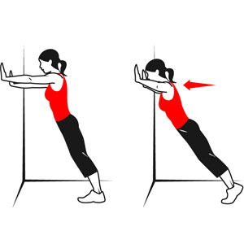
#11 – Jumping
Directions: Jump or march in place.
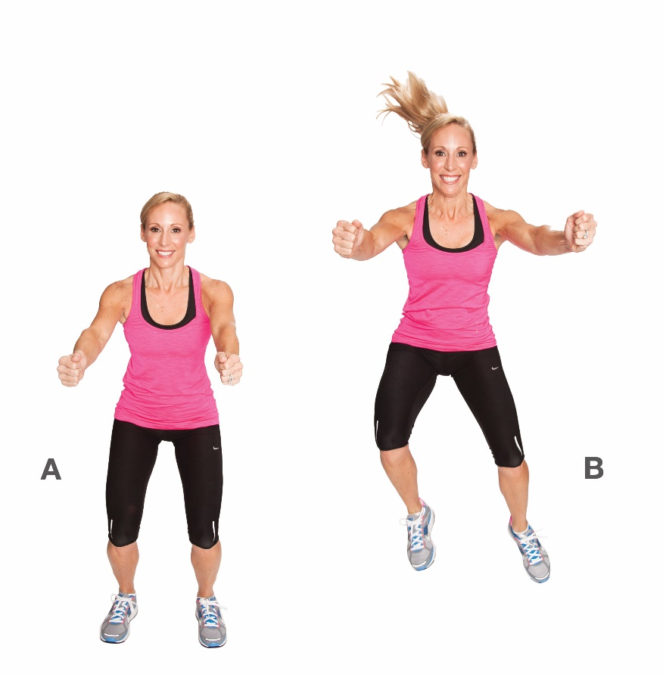

#12 - Count to Ten (slowly and silently in your head)
Directions: SLOWLY count to ten: One one thousand, two one thousand, three one thousand, four one thousand, five-one thousand, six one thousand, seven one thousand, eight one thousand, nine one thousand, ten one thousand. Repeat multiple times slowly.
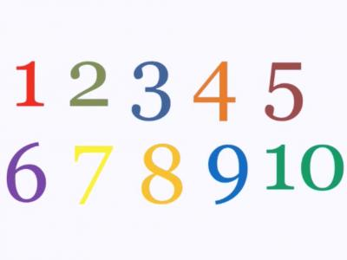
#13 - Deep pressure squishes with a bean bag or oversized pillow
Directions: Lay on the floor and place the weighted pillow over you.
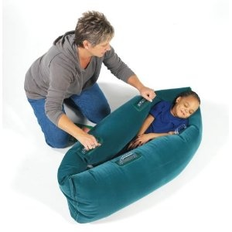
#14 - Bouncing on a Therapy ball
Directions: Sit on the ball and gently bounce, but not too high. Keep your feet on the ground.

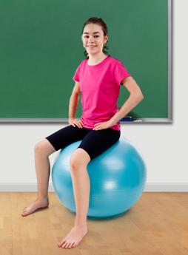
#15 - Velcro under a desk
Directions: Sit on the chair by the desk and gently rub your finger or fingers back and forth on the Velcro underneath the desk.

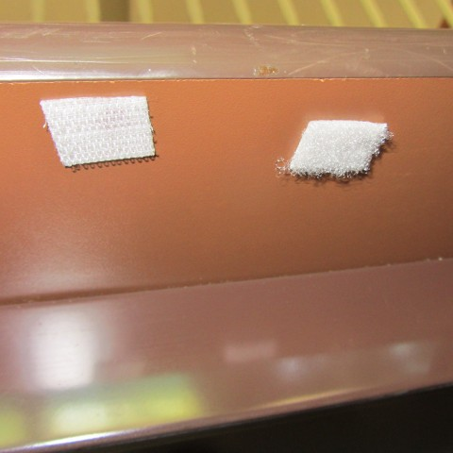

#16 - Run in place
Directions: Quietly run in place.
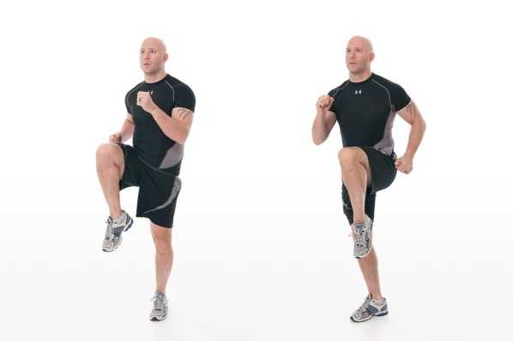

#17 - Stretching station
Directions: Sit at the desk or stand for some of the stretches. Follow the images in the chart below.
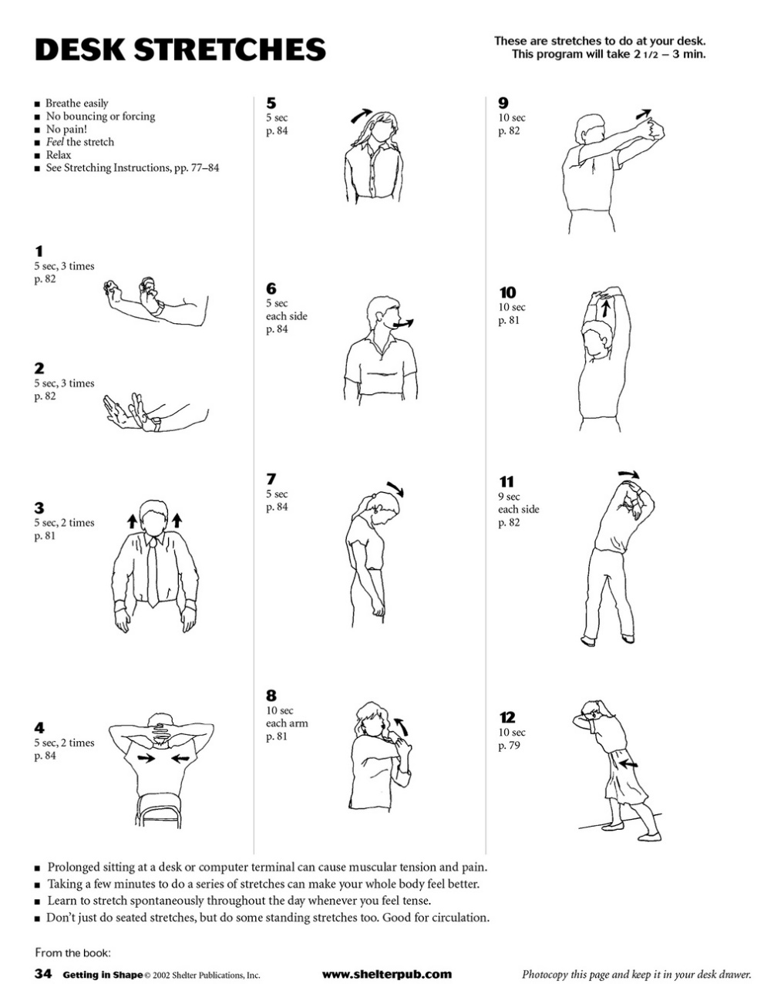
#18 - Calming sequence
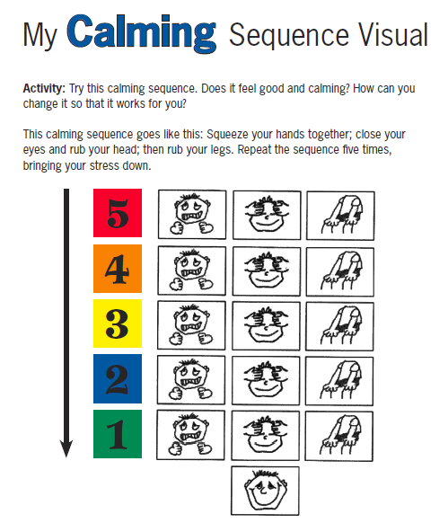
#19 - Move Bouncy Ball between hands
Directions: Place the bouncy ball between your hands with your hands flat and gently roll it around between your hands.

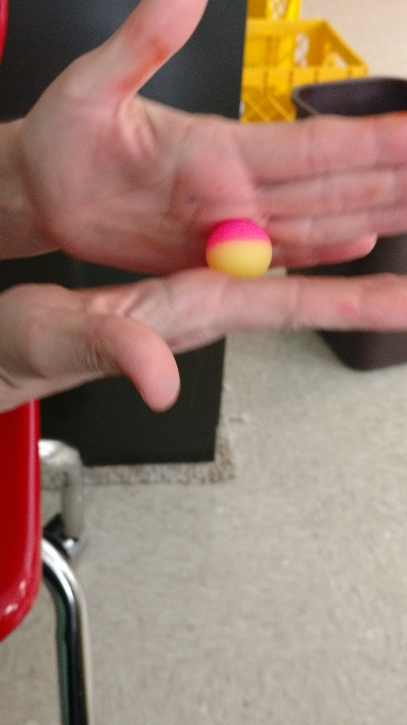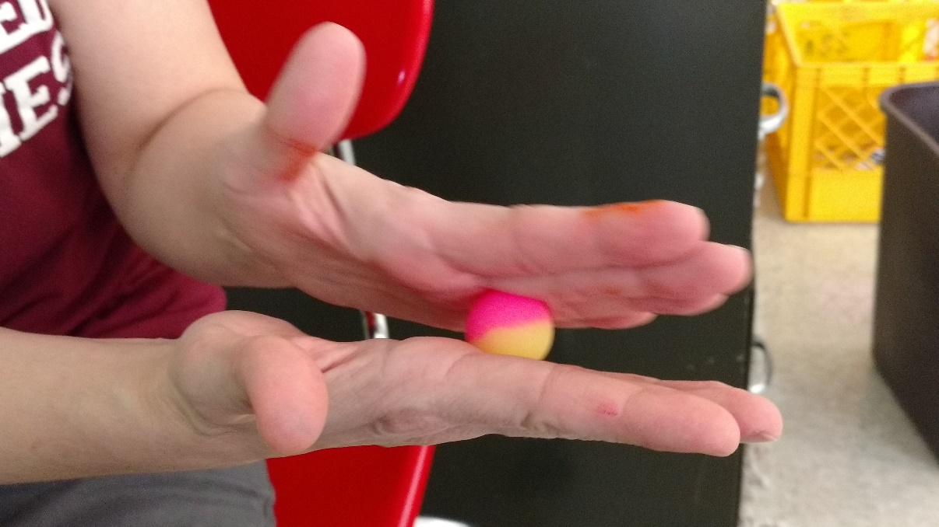
#20 - Finger Hugs
Directions: Take one hand and gently hug each finger on your other hand one at a time. Do not pull.

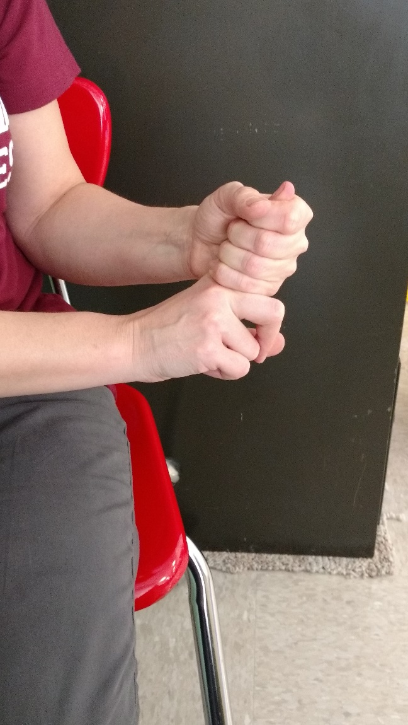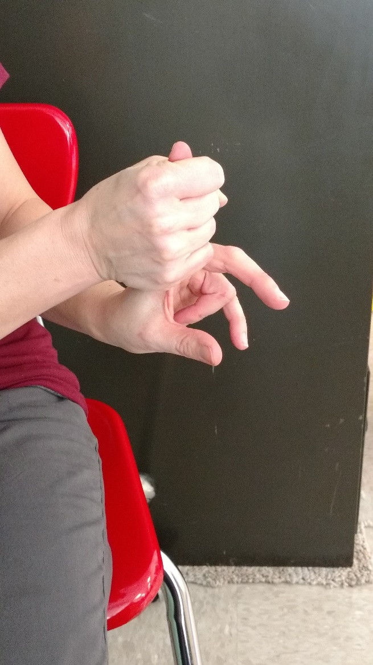
#21 - Netting– rub or squeeze
Directions: Take the netting and rub it on your skin, roll in your hands, or gently squeeze. You can also gently toss it in the air and catch it.

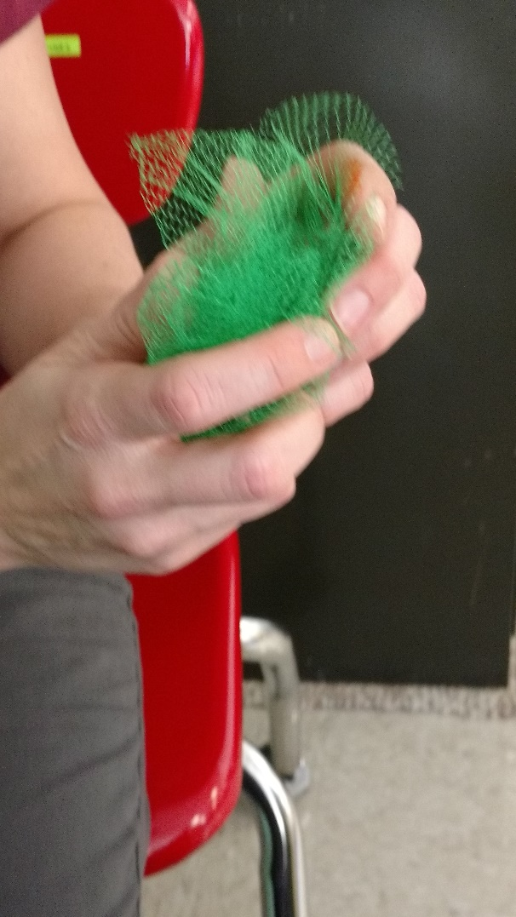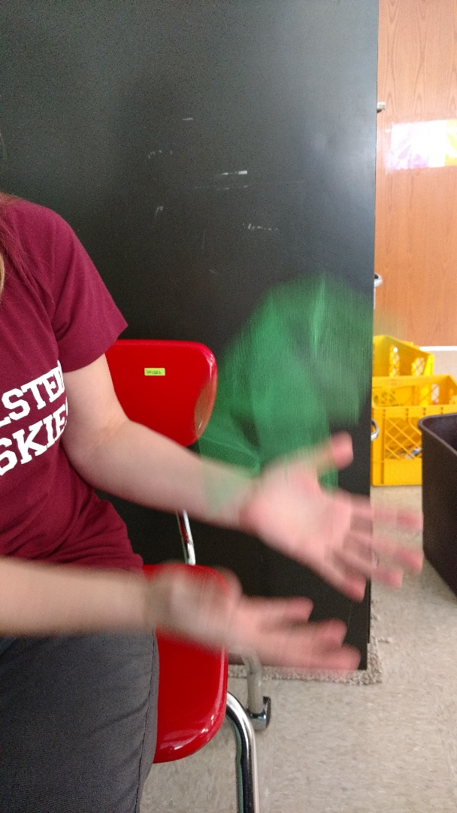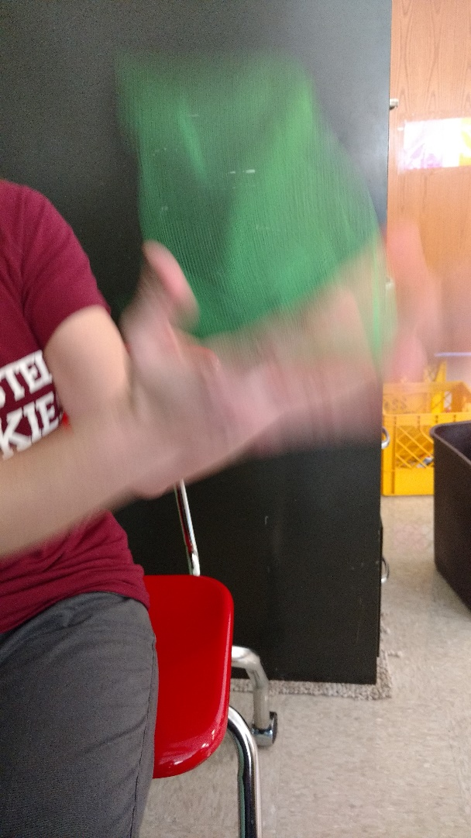
#22 - Stretchy band on leg of desk
Directions: Place your feet on the stretchy band and gently move your feet back and forth.

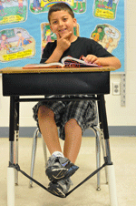
#23 - Deep Breaths
Directions: Imagine you are smelling a rose and blowing out a candle. Slowly repeat until your time at this station is up.

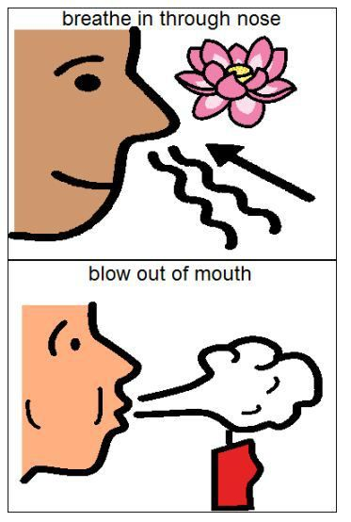

In order by station number, the pictures are derived from the following resources/websites:

#1 – The Zones of Regulation: A Curriculum Designed to Foster Self-Regulation and Emotional Control. A book by Leah M. Kuypers

#2 –https://rtpr.com/9-exercises-improve-finger-dexterity-and-gripping-ability/squeezing-exercisesstress-balls & https://www.aliexpress.com/w/wholesale-smiley-face-stress-ball.html

#3 – https://www.aliexpress.com/promotion/promotion_small-stress-ball-promotion.html

#4 – http://bibibuzz.co.za/greenbean-educational-products/active-play/bean-bags-square-small-4pc

#5 – https://www.sisseluk.com/product/8974_https-www-sisseluk-com-product-8974_theraputty_by_sissel.php.php

#6 – The Zones of Regulation: A Curriculum Designed to Foster Self-Regulation and Emotional Control. A book by Leah M. Kuypers

#7 – Personal picture – not from internet

#8 – http://www.flaghouse.com/Sensory-Solutions/Proprioception/FlagHouse-Weighted-Lap-Pad---Small.axd

#9 – http://www.sony.com/electronics/noise-canceling-headphones

#10 – https://www.pinterest.com/explore/wall-push-ups/

#11 – http://dawnastone.com/uncategorized/fit-5-workout-week-1-day-3/ & https://www.pinterest.com/pin/419608890260544290/

#12 – http://www.playrific.com/m/4796/count-to-ten-in-hopi-native-american

#13 – https://www.pinterest.com/mikalawomack/spd/

#14 – https://www.pinterest.com/heatherie73/balance-balls/

#15 – http://www.avspeechtherapy.com/2013/07/03/sensory-support/

#16 – http://runguate.com/run/?p=1932

#17 – https://www.shelterpub.com/fitness-guides/

#18 – The Zones of Regulation: A Curriculum Designed to Foster Self-Regulation and Emotional Control. A book by Leah M. Kuypers

#19 – Personal picture – not from internet

#20 – Personal picture – not from internet

#21 – Personal picture – not from internet

#22 – https://www.pinterest.com/jewhite76/learning-kinesthetic/

#23 – https://www.pinterest.com/annew4102/take-a-deep-breath/

